**3d Image Interactive Registration System**

**User 's Manual**

**table of Contents**

1. INTRODUCTION 2

1.1. Writing Purpose 2

1.2. Background 2

2. SOFTWARE OVERVIEW 2

2.1. Goal 2

2.2. Function 2

3. OPERATING ENVIRONMENT 2

3.1. Hardware Environment 2

3.2. Software Environment 2

Third-party Library: Opencv, Vaa3D 3

4. OPERATING INSTRUCTIONS 3

4.1. Installation And Initialization 3

4.2. Interface Introduction 3

4.2.1.Image Loading Module 3

4.2.2.Image Display Module 4

4.2.3.Image Enhancement 6

4.2.4.Boundary Contour Alignment 8

4.2.5.Image Registration 10

4.2.6.Node Storage Function 11

4.3. Steps 11

4.3.1.Import point information file 11

4.3.2.Import the image to be registered 12

4.3.3.Preparation Before Registration 14

4.3.4.Registration 17

4.3.5.Update image 17

4.4. Shortcut Key Illustration 18

# INTRODUCTION

## Writing Purpose

The purpose of this manual is to allow users to quickly grasp the functions and detailed usage of this system.

The intended readers of this manual are direct users of the 3D image interactive registration system.

## Background

In order to further improve the accuracy of image registration on the basis of the automatic registration algorithm, manual interaction methods are currently used to obtain feature points. However, manual labeling takes a lot of time and cost, and has relatively high professional requirements for labelers. Therefore, it is meaningful to build a system that does not need to manually label feature points to reduce the burden on the labelers.

# SOFTWARE OVERVIEW

## Goal

In order to solve the defects of manual labeling feature points, the control nodes generated by Bezier curve are used to replace the manually labeled feature points. At the same time, a series of functions are used to realize the semi-automatic registration of manual interaction. The pre-registration results obtained by other methods are improved.

## Function

Image display management, boundary alignment, magnetic Lasso, image registration and image enhancement.

# OPERATING ENVIRONMENT

## Hardware Environment

Monitor screen size: 19-24 inches

CPU：i7-4770 3.40GHZ

Running memory: 16G

## Software Environment

Operating System: Windows Series

Development Tools: Visual Studio 2013, QT5.6

Development Framework: QT

Development Language: C++

Third-party Library: Opencv, Vaa3D

# OPERATING INSTRUCTIONS

## Installation And Initialization

This software does not need to be installed, it can be used directly by opening the exe file.

## Interface Introduction

The main interface of the software is as follows:

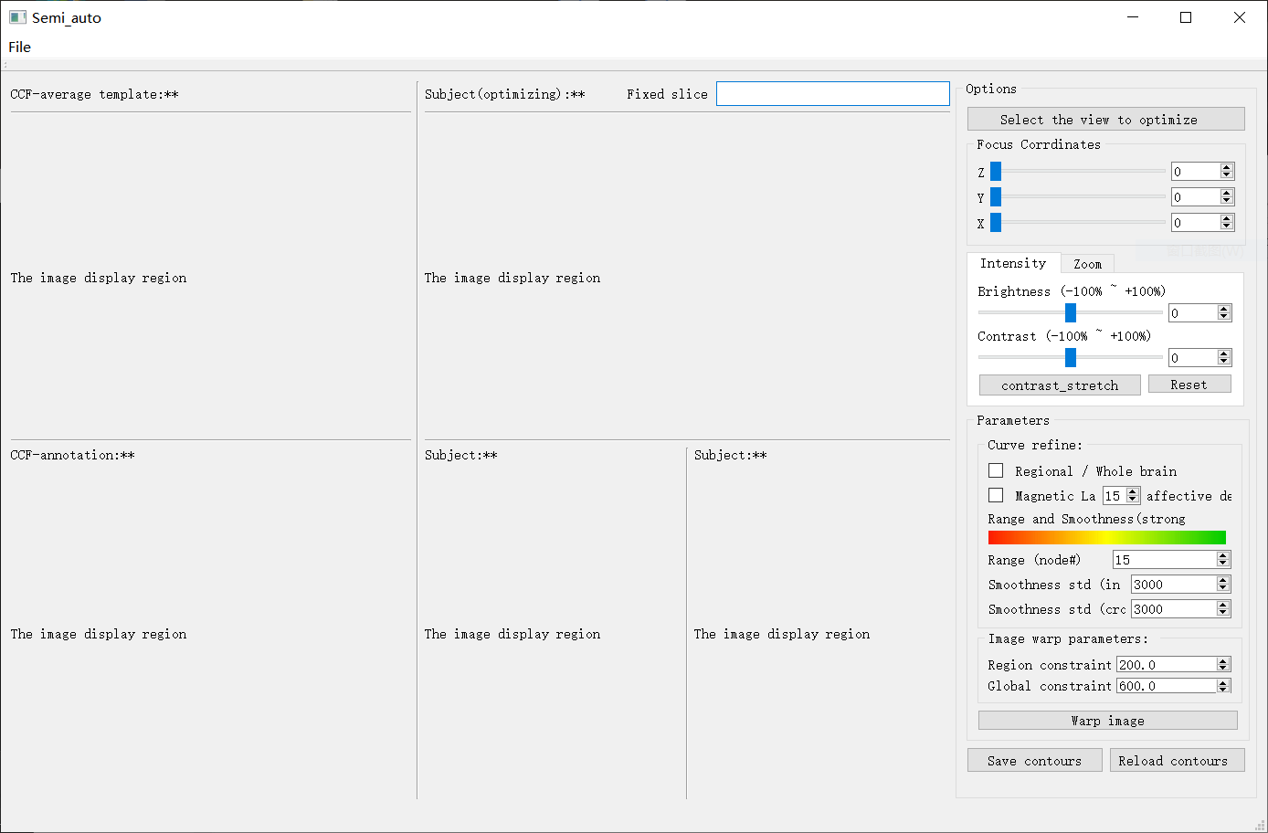

**Figure1 System overall interface renderings**

The following describes the role of each part of the interface and how to use it.

### Image Loading Module

The image loading module is located in the menu bar at the top of the main interface. The user clicks **File-> Open the image** in the menu bar to select the image after the last registration and the image to be registered in the pop-up window.

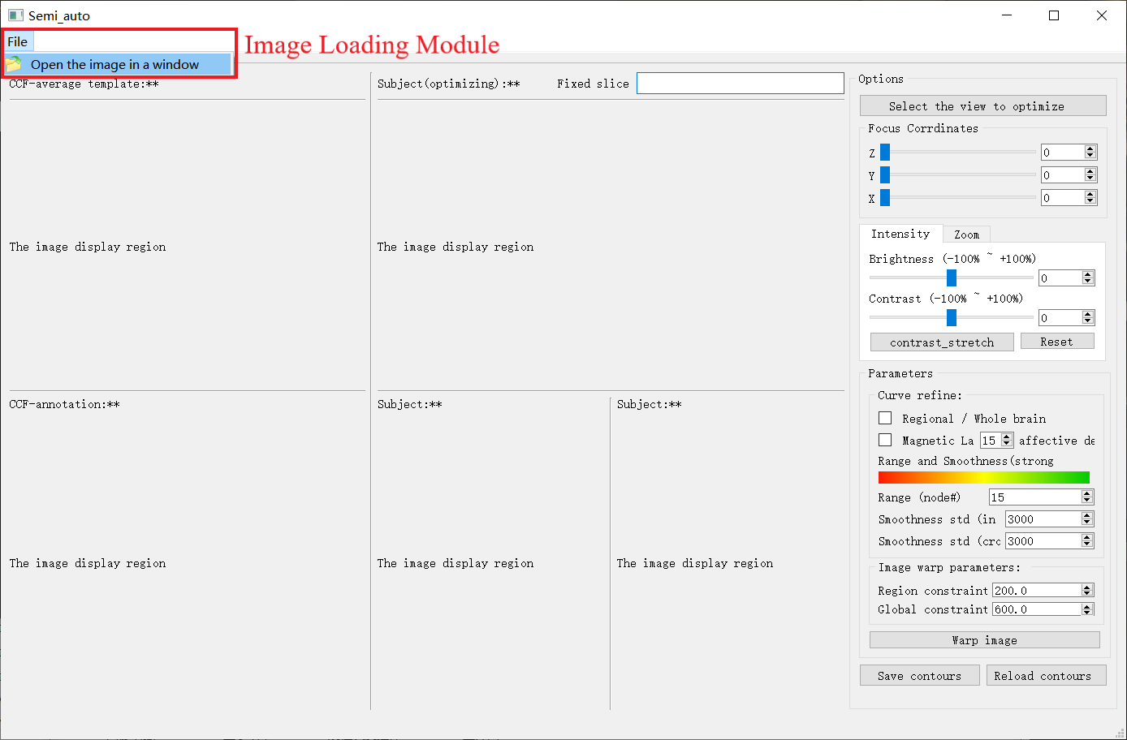

**Figure 2 Image loading module**

### Image Display Module

The central area of the system interface is used to display the registered image. The right side of the display area displays the registered image sequences of the three views, and the left side respectively shows the template image sequence and the label image sequence corresponding to the upper right sequence. The display effect is as follows:

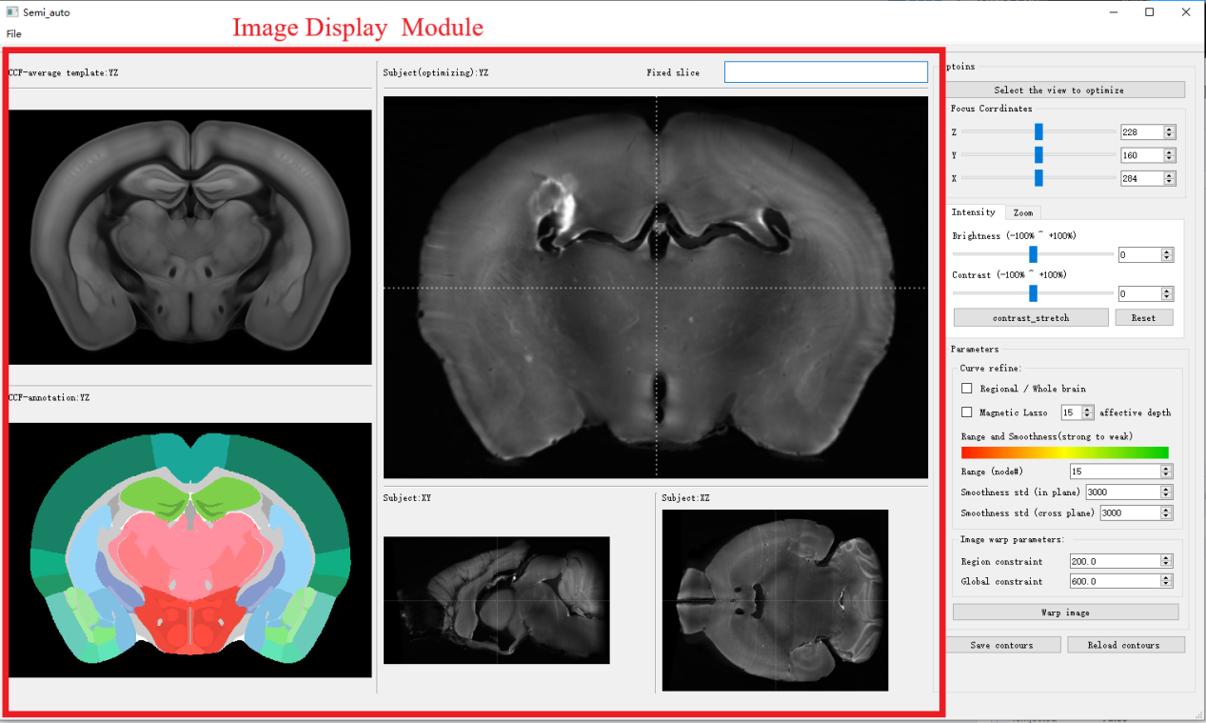

**Figure 3 Image display module**

In addition to the main display area, we can also view the previous or next image in the image sequence through the slider or the mouse wheel in the **Focus Corrdinates** of the interface toolbar.

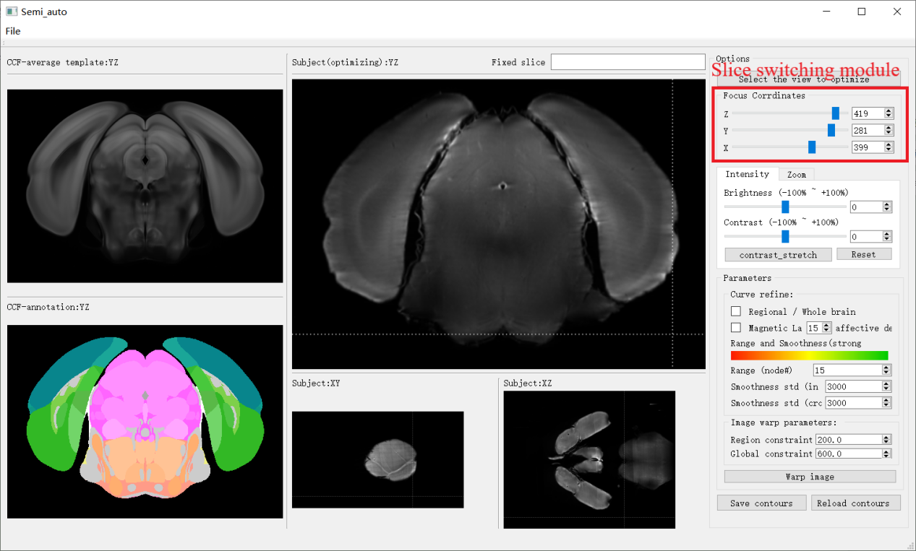

**Figure 4 Slice switching module**

You can use **Options->Select the view to optimize** on the right side of the interface to select different views of the image to be registered.

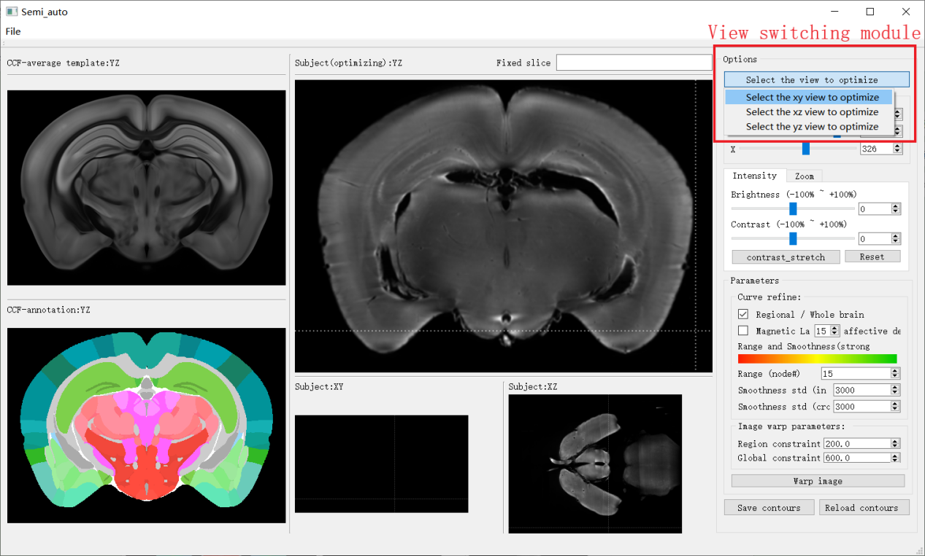

**Figure 5 View switching module**

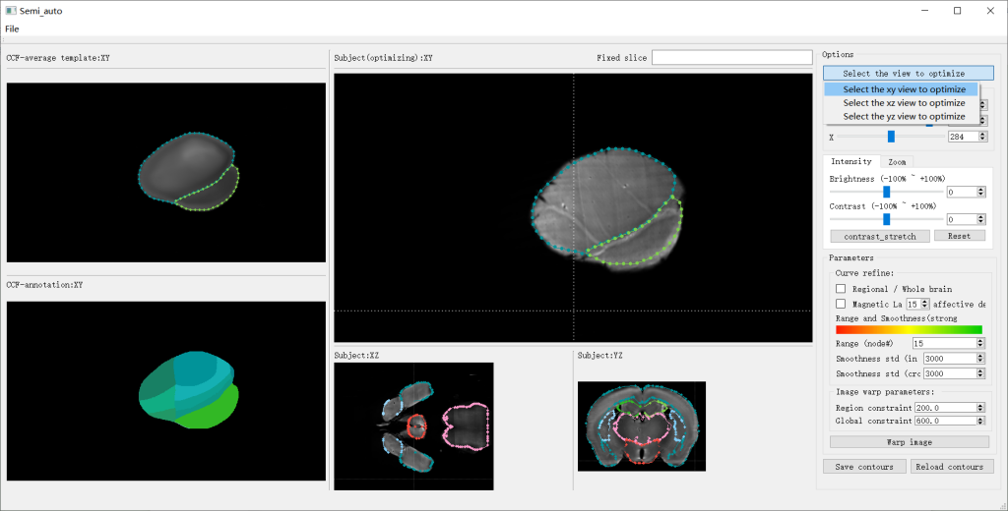

**Figure 6 View switching display**

### Image Enhancement

1. Brightness and contrast adjustment

You can adjust the brightness and contrast of the image through the corresponding tools in the **Intensity** toolbar. There are two horizontal slider modules in this area. The upper slider is used to adjust the brightness of the current main view image, and the lower slider is used to adjust the contrast of the current main view image.

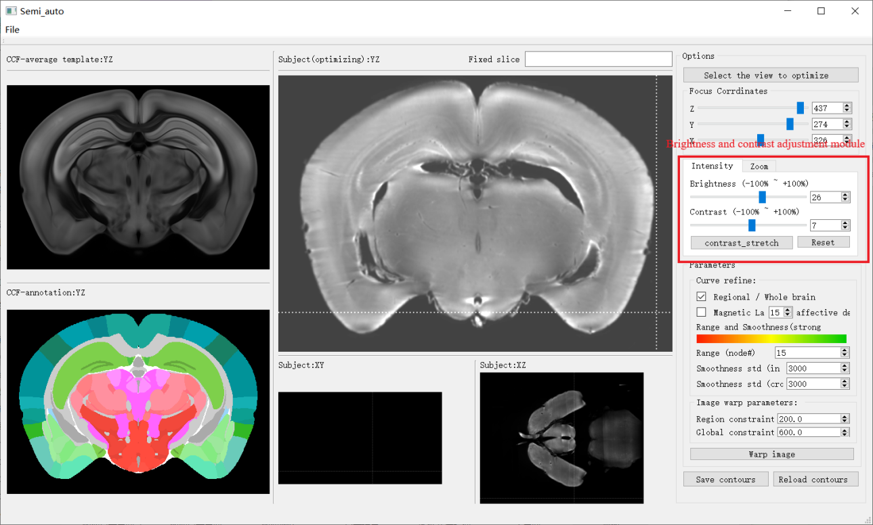

**Figure 7 Brightness and contrast adjustment module and effect display**

1. Gray linear adjustment

By clicking the **Contrast_stretch** button, the gray-scale linear transformation operation is applied to the image, and the boundary contour of the image is enhanced to facilitate subsequent curve adjustment.

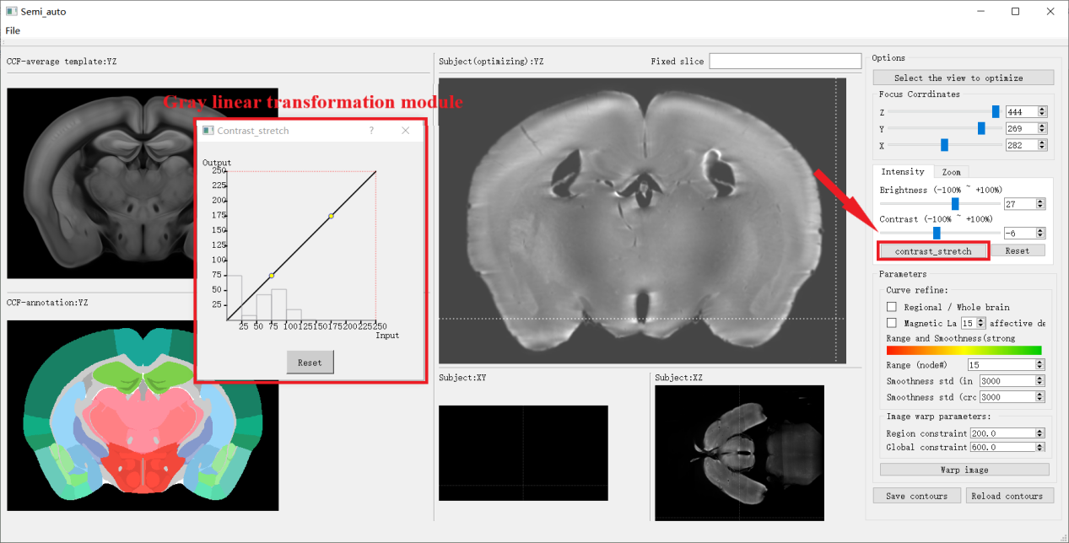

**Figure 8 Gray linear transformation module**

Comparison before and after gray scale linear stretching.



**Figure 10 Display of gray scale linear transformation effect**

1. Image size adjustment

The user can zoom in and out of the image through the corresponding tools in the **Zoom** toolbar. The first item zooms the main view, and the second item zooms the sub view. The default magnifications of these two items are 1.5 and 0.5 respectively.

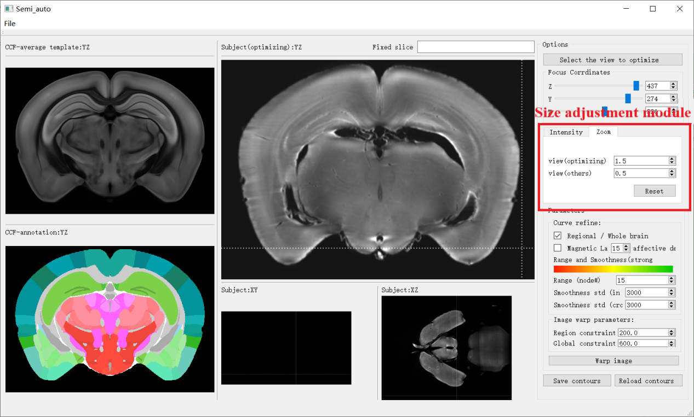

**Figure 11 Size adjustment module**

### Boundary Contour Alignment

1. Regional/Whole brain

Users can choose to adjust the boundary curve of a single region or the boundary curve of a global coherent region by checking the **Regional/Whole brain** check box in the **Curve refine** column on the right side of the interface.

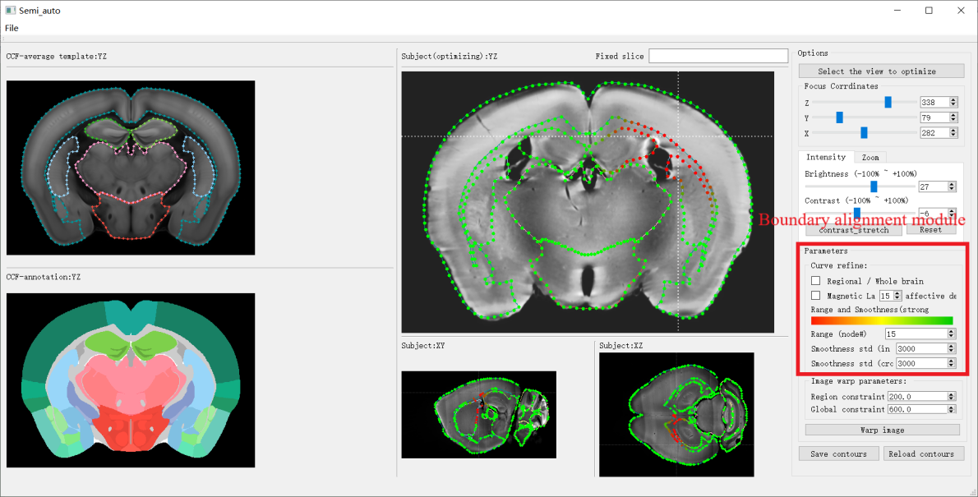

**F**i**gure 12 Boundary alignment module**

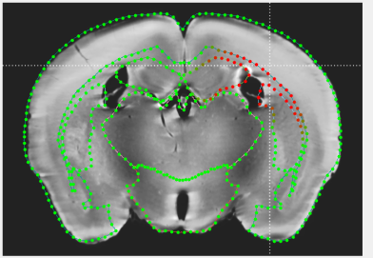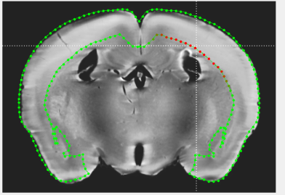

**Figure 13 Comparison of Regional/Whole brain checked, the left picture is unchecked, and the right is checked.**

1. Magnetic Lasso

The user selects whether to use the magnetic lasso tool by checking the **Magnetic Lasso** checkbox in the **Curve refine** column on the right side of the interface. You can also control how many layers are being adjusted at the same time with the current layer as the center by changing the number of **affective depth** in the parameter column on the right.The following figure shows the fit of the front and back borders of the magnetic lasso.

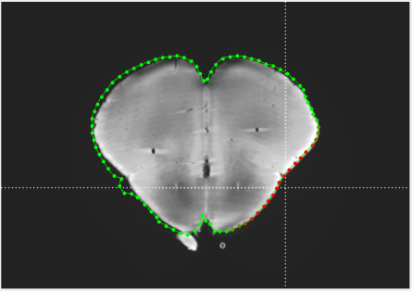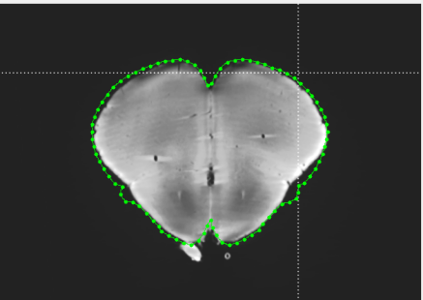

**Figure 14 The effect of using the magnetic lasso**

1. Range parameters

The function of the Range parameter is to define the range of the moving curve, namely the number of control points. This number represents the number of control points before and after the selected certain control point.

1. Smoothness parameter

The system provides two smoothness parameters for adjustment, namely the **smoothness std (in plane)** parameter in the plane and the **smoothness std (cross plane)** parameter perpendicular to the plane axis. By adjusting these two parameters, the smoothness of the curve can be controlled. The user can intuitively see which part of the curve changes and the size of the deformation by observing the color strength of the control points on the curve. and then drag the control points on the image to change the shape of the curve.

### Image Registration

After all the boundary curves of the regions to be optimized in the current optimization view are adjusted correctly, select the appropriate size of the STPS constraint parameters in the image warp parameters in the parameter bar. The larger the parameter value, the greater the constraint, and then click the **Warp image** button below to perform the registration image. Then a circular progress bar will appear, and after the registration task is completed, a registration end message box will pop-up. The user can use the Ctrl + U shortcut key to update the registered image and display it in the three-view display area, and check the effect of fine-tuning by observing the degree of overlap between the curve and the actual area boundary.

The system provides two STPS constraint parameters, namely the local constraint parameter Region constraint and the global constraint parameter Global constraint. The user can adjust them according to the specific situation.

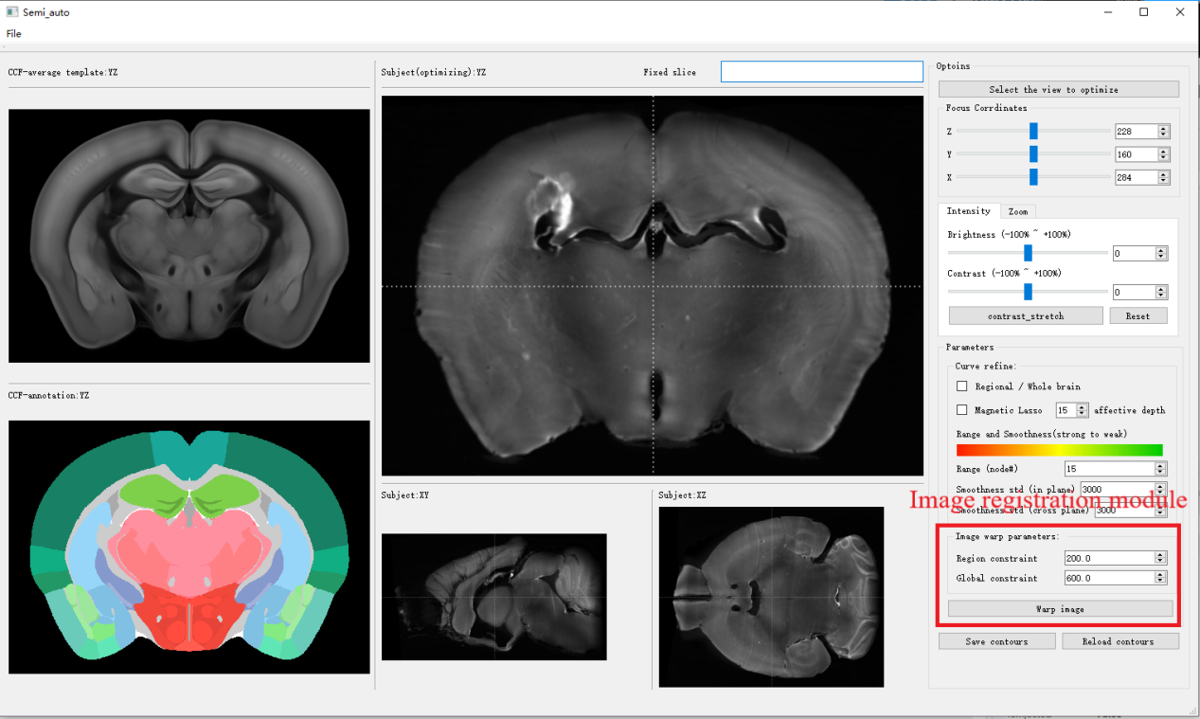

**Figure 15 Image registration module**

### Node Storage Function

In order to prevent the system from crashing during actual use, causing the user to lose information in the part that has been registere. the system provides storage and import functions, allowing users to save all current control points location information, It can be re-imported when it is opened next time to continue the registration work. This function reduces the user's workload.

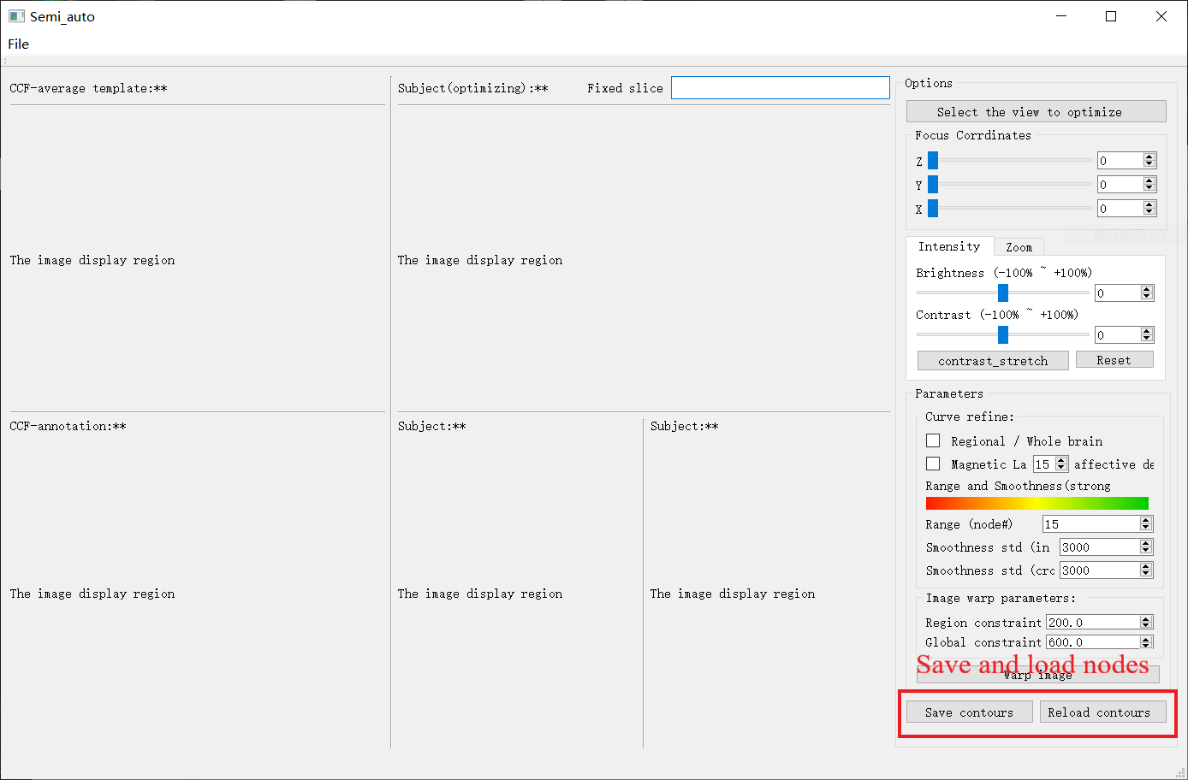

**Figure 16 The button on the left is used to save and the button on the right is used to load**

## Steps

### Import Point Information File

Import a set of marker point files (on the image to be registered and the template image) generated from the automatic registration result. before starting the registration work, first import a set of marker point files generated by the automatic registration into the system. The relative path of the system record point information is data\base_marker, and the file name is in a fixed format, namely sub.marker and tar. marker. This set of marker points corresponds to the image after registration.

This step is not a necessary step. The user only need to update the point file before loading the image file to be registered for the **first time**.

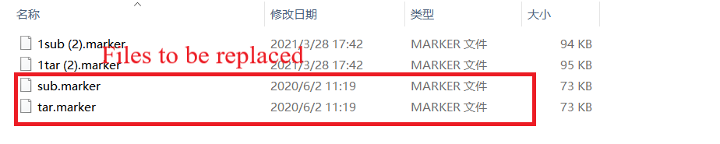

### Import the image to be registered

Click the exe file in the main folder to open the software and start importing the file to be registered. Proceed as follows:

1. Click **File-> Open the image** in the menu bar.

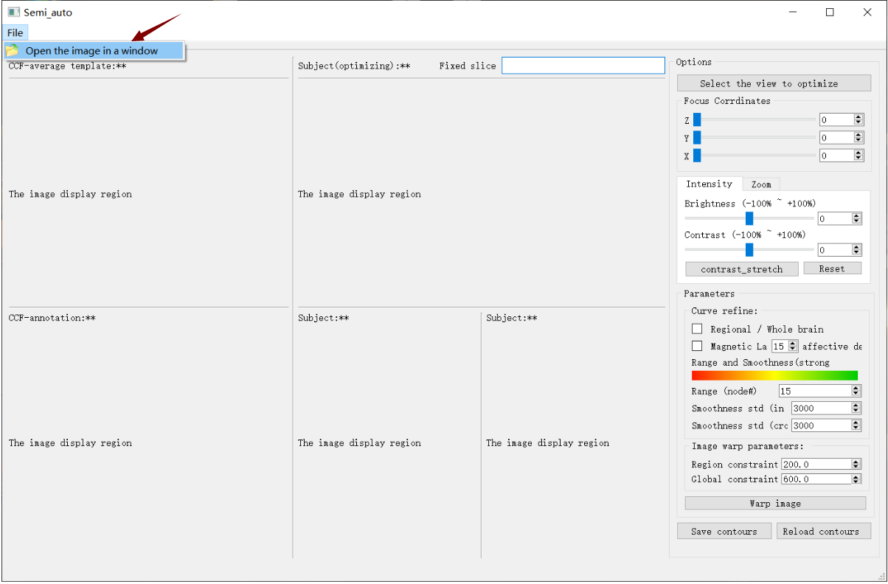

1. In the pop-up window, select the image file that needs to be improved after registration by other methods.

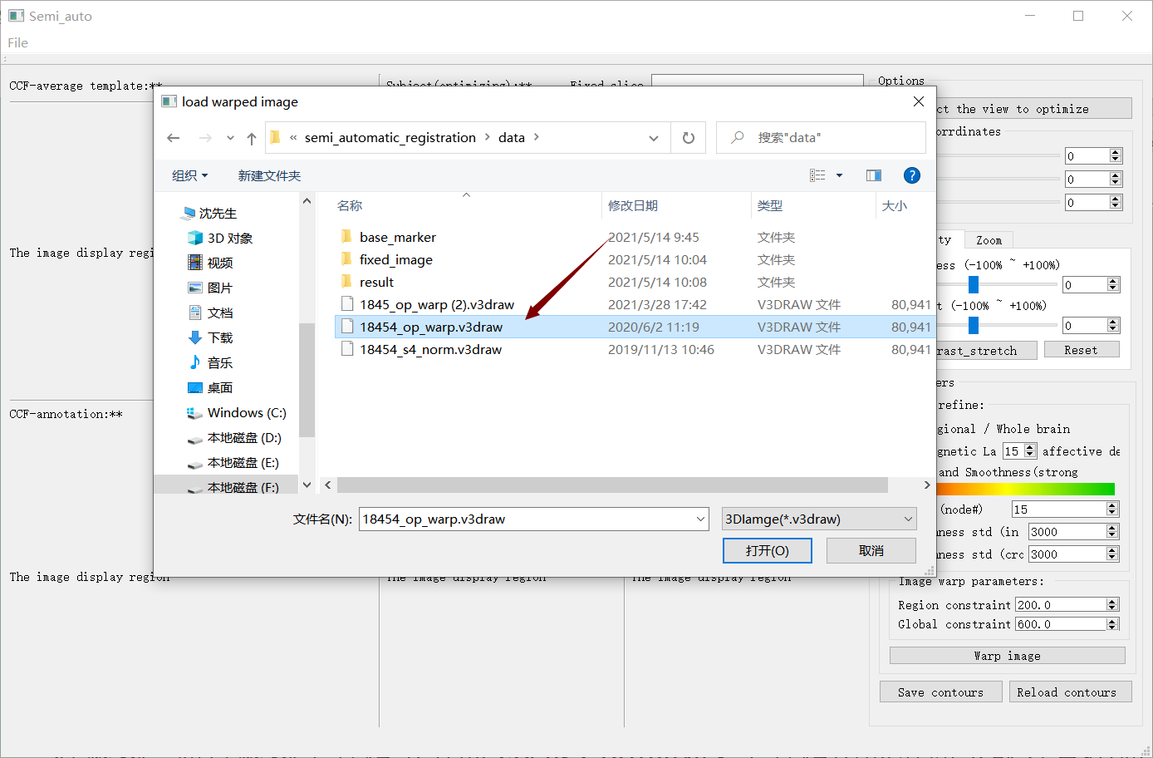

1. After the first selection is completed, a window will pop up again, this time select the original image file corresponding to the registered image.

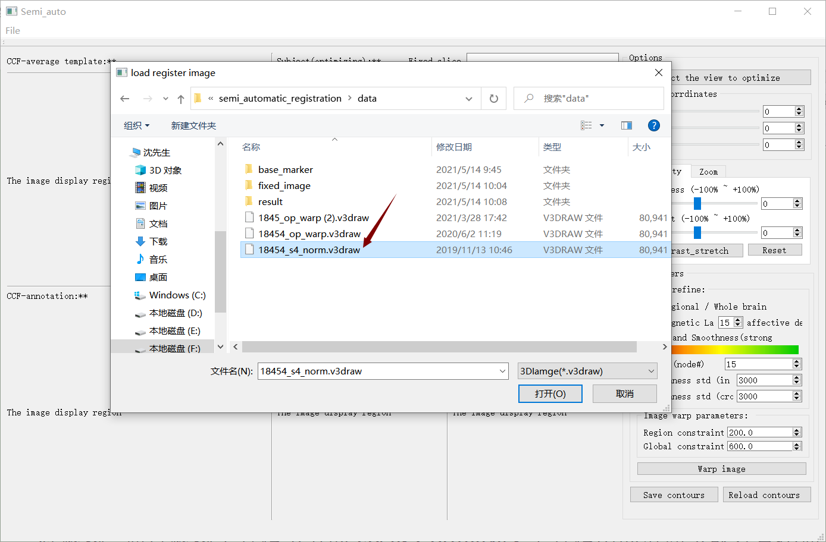

After two selections, the system will load the image to be registered and display it in the display module.

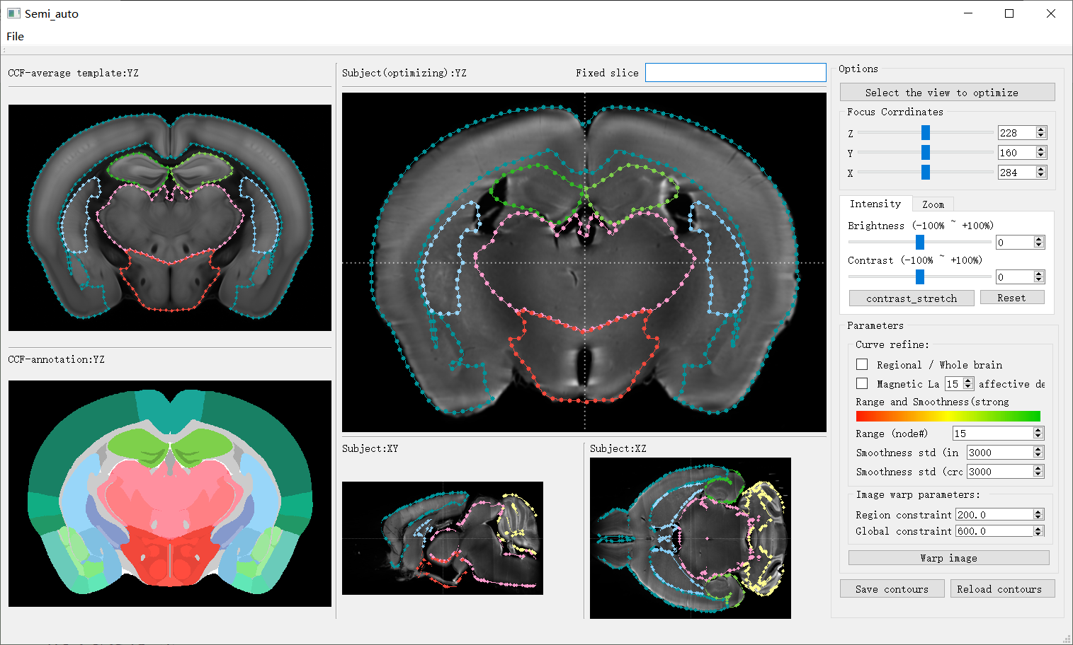

### Preparation Before Registration

1. View And Slice Selection

After the file is loaded successfully, some simple settings are needed to start the registration work. First select the registered view and slice, you can do it through the **Options->Select the view to optimize** menu in the toolbar on the right side of the interface, and view the image slice through the slide bar in the **Focus Corrdinates** toolbar below the view toolbar or directly use the mouse wheel to view the previous or next image slice sequence.

1. Instructions For Brightness And Contrast Adjustment

After adjusting to the appropriate view and slice picture, if the current slice of the image is not very clear, you can adjust the brightness and contrast of the image through the image enhancement module. you can also use the grayscale curve to adjust the grayscale distribution of the image.

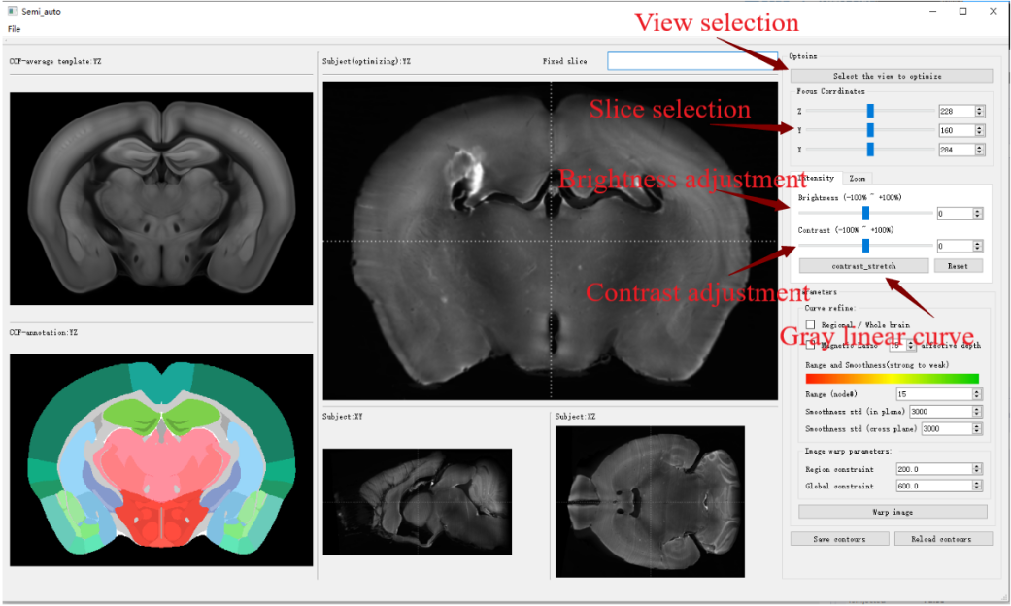

1. System parameter adjustment instructions

Finally, you need to adjust some system parameters of the registration work. These parameters are concentrated in the boundary alignment module. It should be noted that the settings of these parameters are not static. In order to complete the registration work more easily and accurately, We can dynamically adjust these parameters according to the characteristics of the current image.

First, you can choose to adjust the boundary curve of a single region or the boundary curve of a global coherent region by checking the Regional/Whole brain check box in the Curve refine column on the right side of the interface. Generally, this check box will be selected to facilitate our registration work for a single area.

The magnetic lasso tool can be selected according to the situation. The magnetic lasso can save us a lot of time and energy when the edge of the image is obvious. However, the performance of this function is not very ideal in some fuzzy borders.

By adjusting the number of control points on the curve and the parameters of smoothness, it can help us to operate a series of sliced images at the same time. When we perform registration operations on the current image, the curve smoothness parameter determines the degree of influence of our operation on adjacent slices. This influence is consistent with the Gaussian function model. The smoothness std (in plane) parameter and The smoothness std (cross plane) parameter perpendicular to the plane axis represents the standard deviation in the Gaussian function. The larger the parameter, the wider the opening width of the function, the more slices are affected. Take the current slice layer as the center, the attenuation changes on both sides are present. The default parameters are 3000. Generally, we recommend setting the influence depth to about 5 and the smoothness parameter to 500 to 1000. As the user's proficiency increases, this value can be increased appropriately. In order to visualize these two smoothing parameters more visually, the user can intuitively see which part of the curve changes and the size of the deformation by observing the color strength of the control points on the curve, and then use the mouse to drag the control points on the image to change the shape of the curve..

1. Pull The Curve To Align

After completing the initial settings, you can start the registration work. When you choose to optimize a single area, double-click the area to be optimized with the mouse, the system will display the boundary contour curve of the corresponding area and the control points on the curve, click again to select a point, and the number of control points of the Range parameter before and after the point will be Turns to red, these points are in an operational state now. We can adjust the position of the boundary line by dragging these points with the mouse to align with the edge of the image to achieve a registration effect. Decide whether to use a magnetic lasso according to the specific situation.

Note: Some points to note in the process of boundary alignment:

1. It should be noted that every operation of the user affects not only the current slice, so the user should pay attention to the situation of multiple slices before and after during the registration process to prevent us from aligning the boundaries of the current slice but disrupting the already aligned boundary lines of adjacent layers.

2. In the same way, in order to prevent the aligned results from being affected by subsequent operations, you can press shift to lock all the boundary lines and control points in the aligned slices, so that they will not be affected, and the work results will be saved. These locked settings will disappear when the image is reloaded, and we need to lock it again. The quicker way is to hold down the Shift key and slide the scroll wheel, so that you can quickly lock a series of images.

3. Generally speaking, there are multiple independent regions that need to be registered in a slice image. When the **Regional/Whole brain** option is checked and only a single region is registered, it is easy to cause the registration result to overlap with other regions. At this time, we can use the shortcut key Ctrl+T to display the boundary lines of all regions as a reference to facilitate the user's registration work.

4. Even if we set the smoothing parameters, we will find that the boundary line of the sliced image in the back will produce a very large distortion. This is the result of the continuous accumulation of the influence of the user's previous adjustment curve operation on the subsequent image. In this case, the system provides the reset shortcut key. There are two reset shortcut keys. Ctrl+R is a global reset, which will restore the boundary lines of all slices in the image sequence to the initial state. In contrast, Ctrl+F is more commonly used, and its function is to restore all the boundary lines of the sliced image in the current optimized area that are not locked to the initial state, so that the above problems can be solved.

### Registration

After we finish aligning the boundary of a view, we need to perform the final registration work. This function is enabled through the Warp Image button, but before that, we must first set the STPS constraint parameters. By selecting the appropriate size of local and global STPS constraint parameters in the parameter bar Image warp parameters. the larger the parameter value, the greater the constraint. Click the **Warp image** button below to register the image to be registered, and then a cycle of progress bar will appear. After the registration task ends, a registration end message box will pop up. The user can use the Ctrl + U shortcut key to update the registered image and display it in the three-view display area. We can check the effect of fine-tuning by observing the degree of overlap between the curve and the actual area boundary. The result of one registration may not be very satisfactory. We can further improve the final result through multiple registrations.

The STPS constraint parameter used in the first warp will be relatively large, and this value can be gradually adjusted to obtain the desired result when the registration is repeated later.

### Update image

After the warping work is completed, two point files and one image file will be generated in the result folder of the software. This is the result of warp. It should be noted that if you want to reopen the software after the warp is completed, and continue to work with the results of the previous warp, you need to use the op_warp.v3draw file in the result to replace the pre-registered image file for loading.

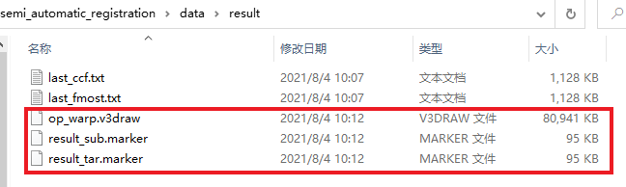

## Shortcut Key Illustration

Shift: Lock or unlock the curve of the current image.

Ctrl+C: Unlock the locked curve.

Ctrl+F: Reset the unlocked curve.

Ctrl+Z: undo the last adjusted curve.

Ctrl+T: When optimizing a single area, show or hide the boundary curves of other areas.

Ctrl+O: Show or hide the boundary curve of a single area.

Ctrl+P: Show or hide the control points on the boundary curve.

Ctrl+N: Show or hide the number of control points on the boundary curve.

Ctrl+U: Update the registered image and display it in the three-view display area.

Ctrl+R: global reset